Fashion Rental Hub

Aditya Bharti   
*Apex Institute of Technology-AIML*  
Chandigarh UniversityMohali, Punjab  
21bcs6514@cuchd.in  
  
Vaibhav Verma  
*Apex Institute of Technology-AIML*  
Chandigarh UniversityMohali, Punjab  
21bcs6557@cuchd.in  
  
Aastha Khandelwal  
*Apex Institute of Technology-AIML*  
Chandigarh UniversityMohali, Punjab  
21bcs6412@cuchd.in  
  
Mr. Jaswinder Singh  
*Asst. Professor Apex Institute of Technology*  
Chandigarh UniversityMohali, Punjab  
jassi724@gmail.com

*Abstract* — Our Fashion Rental Hub is a revolutionary platform that redefines the fashion industry through a comprehensive rental service. Leveraging the power of the MERN (MongoDB, Express.js, React.js, Node.js) stack, our platform offers an end-to end solution with seamless user authentication, dynamic product listing, advanced filtering options, and a secure payment gateway. Administrators benefit from a complete dashboard providing insights into product sales and performance metrics, with support for multiple admin accounts. With a diverse range of clothing options available for rent across various categories and price points, users enjoy a convenient shopping experience enhanced by an AI-based recommendation system. The platform prioritizes sustainability and environmental conservation by promoting renting over buying, thus reducing fashion waste. Join our Fashion Rental Hub today to experience the future of fashion rental services, where style, convenience, and sustainability converge.

**Keywords— MERN stack, Dynamic product listing, User authentication**

# Introduction

## Problem Definition

Our platform offers an end-to-end solution, ensuring a seamless experience for every user. From user authentication to dynamic product listing, filtering options, and a secure payment gateway, we’ve got you covered every step of the way. At our Fashion Rental Hub, convenience meets sophistication with our dynamic product catalog. Explore a diverse range of clothing options across multiple categories and price points, curated to suit every style and occasion. Whether you’re searching for the perfect cocktail dress or a casual ensemble, our extensive collection has something for everyone.

## **Problem Overview**

With our intuitive order summary and dynamic shopping cart facility, managing your rentals has never been easier. Simply add your desired items to your cart, review your order summary, and proceed to checkout seamlessly. Plus, our AI-based recommendation system takes the guesswork out of finding your next favorite piece by suggesting similar products tailored to your preferences. Behind the scenes, our complete admin dashboard empowers administrators with valuable insights into product sales and performance metrics. With support for multiple admins, our platform ensures efficient management and oversight, allowing for smooth operations and informed decision-making.

# LITERATURE SURVEY

## **Sustainability and Fashion Rental**

Fashion rental platforms promote sustainability by reducing waste and promoting circularity. It is a platforms that are pivotal in fostering sustainability within the fashion industry by fundamentally altering consumer behavior and supply chain dynamics [1]. By shifting from a model centered on ownership to one based on access, these platforms significantly extend the lifespan of garments, mitigating the environmental impact associated with production and disposal. Through the reuse of existing clothing items, fashion rental services effectively reduce carbon emissions and conserve resources like water. Moreover, they incentivize brands and designers to prioritize durability and quality in their creations, further promoting sustainable practices (Grose, 2012). By offering consumers a diverse range of fashion choices without the need for constant purchases, rental platforms cultivate a culture of mindful consumption, aligning with broader sustainability goals (Niinimäki K. &., 2020). As a result, they contribute to the transformation of the fashion industry towards a more circular and environmentally responsible model [2]. Studies have shown that rental platforms can significantly reduce carbon emissions and water consumption compared to traditional retail models [3]. Users seamlessly register/login and browse a diverse clothing catalog with dynamic filtering and AI-powered recommendations. Users select desired items and securely complete the rental payment through a secure gateway. Admins monitor rentals, analyze sales data on a comprehensive dashboard, and manage multiple admin accounts.

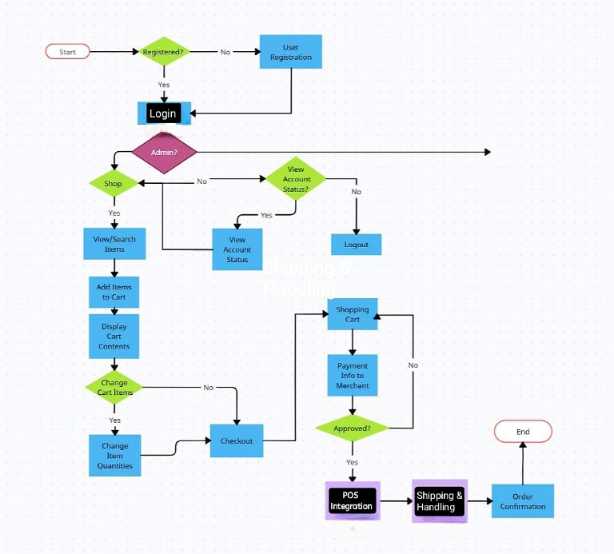

## **Technology and Fashion Rental**

Technology plays a crucial role in enhancing the fashion rental experience. Platforms like Fashion Rental Hub utilize the MERN stack to provide a user-friendly interface, efficient backend functionality, and secure payment systems. The MERN stack enables the development of user-friendly interfaces that are easy to navigate and understand. This is essential for fashion rental platforms, as users need to be able to quickly and easily find the items they are looking for, as well as manage their rentals. It also provides efficient backend functionality, which is responsible for handling the complex operations of a fashion rental platform. This includes managing inventory, processing orders, and tracking rentals. Efficient backend functionality ensures that the platform runs smoothly and that users have a positive experience (Kadam, 2023). Finally, the MERN stack includes secure payment systems that protect users' financial information. This is essential for any e-commerce platform, but it is especially important for fashion rental platforms, as users are often renting high-value items [4]. Advanced features such as personalized recommendations,

virtual try-ons, and seamless checkout processes contribute to a positive user experience [5] .

## **Consumer Motivations for Fashion Rental**

Research has identified various motivations for consumers to rent fashion items (Ruan, 2022). These include sustainability concerns, cost savings, access to exclusive designs, and the desire for variety, Sustainability considerations play a significant role, with consumers increasingly mindful of the environmental impact of their fashion choices and opting for rental as a more eco-friendly option. Additionally, the appeal of cost savings cannot be overstated, as renting offers a more affordable way to access high-end or designer garments compared to purchasing them outright [6]. Moreover, research has highlighted the influence of social media and influencers in shaping consumer perceptions, with platforms like Instagram and TikTok promoting fashion rental as both sustainable and stylish (Ting Chi, 2023). As consumers seek more ethical and convenient ways to engage with fashion, rental services emerge as a compelling solution that meets diverse needs while aligning with evolving values and preferences [7].

## **Case Studies of Fashion Rental Platforms**

Case studies of successful fashion rental platforms provide insights into their business models, marketing strategies, and impact on the industry (Mukendi, 2020). Platforms such as Rent the Runway, Nuuly, and Wardrobe have demonstrated the potential of rental platforms to disrupt traditional retail and promote sustainable fashion practices [8].

## **Exploring the Spectrum of Fashion Rental**

* Fashion rental platforms encompass a spectrum of segments, each catering to distinct consumer preferences and needs. Luxury rental services target clientele seeking access to high-end designer garments and accessories for special occasions or everyday wear, offering a taste of luxury without the hefty price tag of ownership. Subscription rental models provide consumers with regular access to a rotating wardrobe, typically for a monthly fee, appealing to those who value variety and convenience in their fashion choices.
* On the other hand, peer-to-peer rental platforms facilitate transactions between individual users, enabling the renting out of personal wardrobes or the borrowing of items from others within a community, fostering a sense of community and sustainability (Brydges, 2020). Understanding these diverse segments enables fashion rental platforms to tailor their offerings effectively, whether by curating a selection of exclusive luxury items, providing flexible subscription options, or facilitating peer-to-peer exchanges. These segments include luxury rental, subscription rental, and peer-to-peer rental [9].
* By aligning with specific consumer needs and preferences, platforms can enhance their appeal and drive greater adoption of fashion rental as a sustainable and accessible alternative to traditional retail. [10].

# PROPOSED SYSTEM

## Abstract

Fashion Rental Hub, is a revolutionary platform designed to offer users a seamless and sustainable fashion rental experience. It encompasses essential features such as user authentication, dynamic product listing with filtering options, a secure payment gateway, a complete admin dashboard for insights and management, multiple admin support, renting clothes across various categories and prices, order summary, dynamic shopping cart, and an AI-based recommendation system. Utilizing the MERN (MongoDB, Express.js, React.js, Node.js) stack, Fashion Rental Hub leverages the benefits of this modern technology stack. MongoDB ensures flexible and scalable data storage, while Express.js simplifies backend development with its robust framework. React.js provides a responsive and interactive user interface, enhancing the user experience, and Node.js facilitates efficient server-side operations, ensuring smooth performance. The adoption of the MERN stack enables Fashion Rental Hub to deliver a highly responsive, scalable, and efficient platform. Its modular architecture allows for seamless integration of new features and enhancements, ensuring that the platform remains agile and adaptable to evolving user needs. Additionally, the MERN stack fosters rapid development cycles, enabling quicker iterations and updates to the platform, ultimately leading to a more dynamic and innovative user experience.

## Problem Overview

The fashion industry, despite its glamour and allure, is one of the major polluting industries in the world. The environmental impact is significant, largely due to the fast fashion model that encourages consumers to frequently buy new clothes and discard old ones. This model leads to excessive waste, contributing to landfills and pollution. Additionally, the traditional retail model often lacks personalization, failing to cater to individual tastes and preferences. It also often fails to provide a seamless shopping experience, with disjointed processes from selection to payment.

## Existing System

#### The existing system in the fashion industry is the traditional retail model. This model primarily focuses on selling new clothes to consumers, with little regard for the environmental impact. It lacks advanced features like AI-based recommendations, which could provide personalized suggestions based on user preferences. The product listing is static, not dynamic, making it difficult for users to find specific items. The user authentication process is often cumbersome, and the payment gateway may not be secure, leading to potential data breaches. On the administrative side, the features are limited. There is no support for multiple admin accounts, making it difficult to manage large teams. There is also no comprehensive dashboard for sales and performance metrics, making it challenging to make data-driven decisions.

## Propsed System

The proposed system is the Fashion Rental Hub, a revolutionary platform that aims to redefine the fashion industry. This platform leverages the power of the MERN (MongoDB, Express.js, React.js, Node.js) stack to offer a comprehensive rental service. It features seamless user authentication, ensuring a smooth login and signup process. The product listing is dynamic, updating in real-time based on availability and trends. Advanced filtering options allow users to find exactly what they’re looking for, and a secure payment gateway ensures safe transactions. The platform also includes a complete dashboard for administrators, providing insights into product sales and performance metrics. This allows for effective management and decision-making. Support for multiple admin accounts enables efficient team management. An AI-based recommendation system enhances the user shopping experience by providing personalized suggestions. The platform promotes renting over buying, thus prioritizing sustainability and reducing fashion waste.

## Objectives

* Redefine the fashion industry: The platform aims to shift the focus from buying to renting, promoting a more sustainable approach to fashion.
* Seamless shopping experience: With features like dynamic product listing, advanced filtering options, and AI-based recommendations, the platform aims to provide a seamless and personalized shopping experience.
* Efficient administrative system: The platform includes a comprehensive dashboard and supports multiple admin accounts, enabling efficient management and decision-making.
* Promote sustainability: By encouraging renting over buying, the platform aims to reduce fashion waste and contribute to environmental conservation.
* Contribute to a sustainable future: Through its services, the platform aims to make a positive impact on the environment and contribute to a more sustainable future.

# METHODOLOGY

* 1. *Design and Planning:*

User Stories and Functionalities: Comprehensive user stories and functionalities were meticulously defined, encompassing aspects such as user registration, clothing browsing, rental processes, and wishlist creation. This step ensured a clear understanding of user requirements. Wireframes: Detailed wireframes were crafted to visually represent the user interface for both user and admin sections. These wireframes served as a blueprint for the development process, providing a structured layout for interface design. Entity-Relationship Diagram (ERD): An ERD was constructed to illustrate the data model for clothes, users, rentals, and pertinent statistics. This facilitated a systematic approach to data management and relationships within the application.

* 1. *Development:*

Backend Development: The backend infrastructure was established using Node.js in conjunction with the Express.js framework to facilitate API creation. MongoDB was selected as the database solution, with Mongoose serving as the Object Document Mapper (ODM) for efficient data interaction. Secure API endpoints were developed to handle user authentication, clothing management, rental processing, order tracking, and administrative functionalities.

Frontend Development: React.js was employed to construct user interface components catering to clothing browsing, rental management, and user profiles. Communication with the backend API was facilitated through libraries such as Axios for seamless data fetching and transmission. Admin Dashboard: A dedicated admin dashboard was developed, leveraging React components to provide administrators with functionalities such as order viewing, sales statistics analysis by product and category, and rental trend monitoring.

* 1. *Testing and Deployment:*

Unit and Integration Testing: Rigorous unit and integration tests were implemented to validate the functionality and reliability of both backend and frontend components. This phase ensured the identification and resolution of any potential issues prior to deployment. Deployment: The application was deployed to a cloud platform to ensure accessibility and scalability, thus facilitating seamless user interaction and accommodating potential future growth.

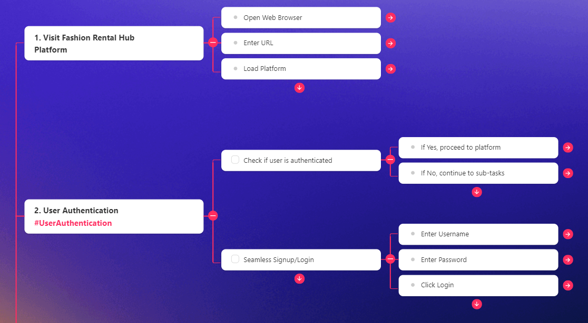

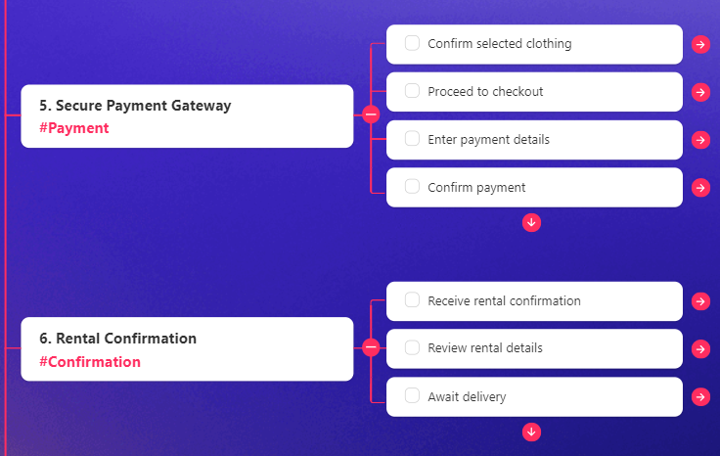

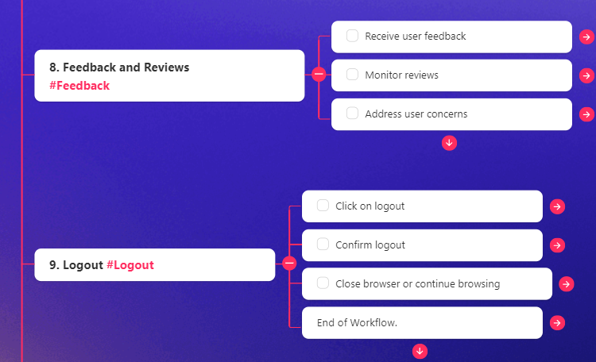

# RESULT AND DISCUSSIONS

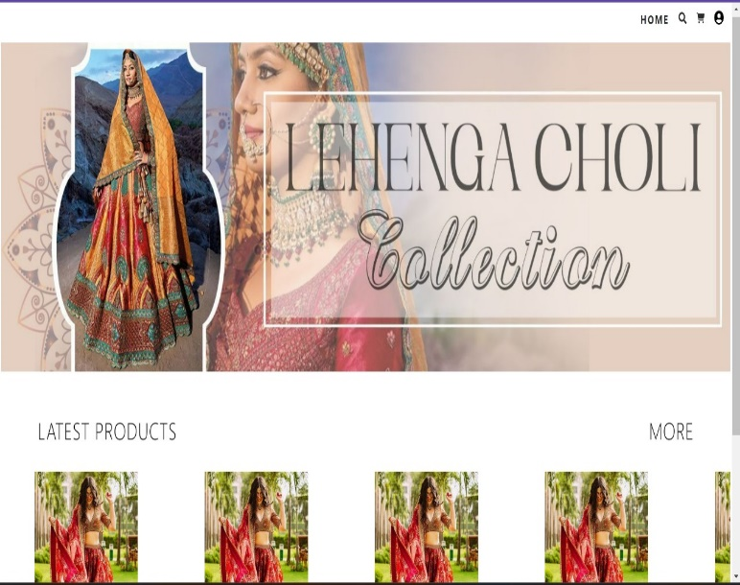

**Fig. 5.** Preview of the homepage

# CONCLUSION AND FUTURE WORKS

The development of the Fashion Rental Hub represents a significant advancement in the domain of online fashion rental platforms. By adhering to a systematic methodology encompassing design, development, testing, and deployment phases, a robust and user-friendly application was realized.

The methodology facilitated a clear understanding of user requirements, leading to the implementation of comprehensive functionalities catering to both users and administrators. The use of modern technologies such as Node.js, Express.js, React.js, and MongoDB ensured efficient data management and seamless user interaction.

* Specialty Collections: Introducing specialty collections tailored to specific demographics or occasions, such as maternity wear, formal events, or athleisure. These curated collections would cater to the unique needs and preferences of different customer segments, enhancing the platform’s appeal and versatility.
* Expanded Size Range: Ensuring inclusivity in sizing by expanding the range of available sizes to accommodate a diverse range of body types and shapes. This could involve working closely with suppliers and designers to offer extended size options and promote body positivity.
* International Expansion: Exploring opportunities for international expansion to reach a broader audience beyond the current geographical scope. This could involve establishing partnerships with international suppliers, adapting the platform to accommodate multiple languages and currencies, and navigating logistical challenges associated with cross- border operations.
* Personalization and Recommendation Features: Implementing personalized recommendation features based on user preferences, browsing history, and past rental behavior. Leveraging data analytics and machine learning algorithms, the platform could offer tailored suggestions to enhance the shopping experience and encourage repeat usage.
* Sustainability Initiatives: Prioritizing sustainability by partnering with eco-conscious brands, offering eco-friendly clothing options, and implementing environmentally friendly practices throughout the supply chain. This commitment to sustainability would resonate with environmentally conscious consumers and align with growing demand for ethical fashion alternatives.

Through rigorous testing, potential issues were identified and resolved, guaranteeing the reliability and functionality of the application. Deployment to a cloud platform further enhanced accessibility and scalability, accommodating potential future growth.

##### References

1. Grose, Lynda & Fletcher, Kate. (2012). Fashion and sustainability: Design for Change.
2. Niinimäki, Kirsi & Peters, Greg & Dahlbo, Helena & Perry, Patsy & Rissanen, Timo & Gwilt, Alison. (2020). The environmental price of fast fashion. Nature Reviews Earth & Environment. 1. 189-200. 10.1038/s43017-020-0039-9.
3. Ellen MacArthur Foundation. (2017). A new textiles economy: Redesigning fashion's future.
4. Kadam, Prof & Goplani, Akhil & Mattoo, Shubit & Gupta, Shashank & Amrutkar, Darshan & Dhanke, Jyoti & Kadam, Yogesh. (2023). Introduction to MERN Stack & Comparison with Previous Technologies. European Chemical Bulletin.12.14382-14386. 10.48047/ecb/2023.12.si4.1300.
5. McKinsey & Company. (2022). The future of fashion: A perspective on the industry's digital transformation.
6. Ruan, Yanwen & Xu, Yingjiao & Lee, Hanna. (2022). Consumer Motivations for Luxury Fashion Rental: A Second-Order Factor Analysis Approach. Sustainability. 14. 7475. 10.3390/su14127475.
7. Ting Chi, Victoria Gonzalez, Justin Janke, Mya Phan and Weronika Wojdyla. (2023). The Unveiling the Soaring Trend of Fashion Rental Services: A U.S. Consumer Perspective. Sustainability, 15(19), 14338.
8. Mukendi, Amira & Henninger, Claudia E. (2020). Exploring the spectrum of fashion rental. Journal of Fashion Marketing and Management: An International Journal. ahead-of-print. 10.1108/JFMM-08-2019-0178.
9. Brydges, Taylor & Heinze, Lisa & Retamal, Monique & Henninger, Claudia E. (2020). Platforms and the pandemic: A case study of fashion rental platforms during COVID‐19. The Geographical Journal. 187. 10.1111/geoj.12366.
10. Lee, Stacy & Huang, Ran. (2020). Exploring the Motives for Online Fashion Renting: Insights from Social Retailing to Sustainability. Sustainability. 12. 7610. 10.3390/su12187610.
11. Noe, Heeju & Hyun, Jonghan. (2020). Fashion Renting: An Exploratory Study of User and Non-User Behaviors. 10.31274/itaa.12210.
12. Lee, Stacy & Chow, Pui-Sze. (2020). Investigating consumer attitudes and intentions toward online fashion renting retailing. Journal of Retailing and Consumer Services. 52. 101892. 10.1016/j.jretconser.2019.101892.